English title in bold, centralized, font size 14
Portuguese title in bold, centralized, font size 14
Article Info:
Article history: Received 2024-01-01 / Accepted 2024-11-20 / Available online 2024-11-30
doi: 10.18540/jcecvlXissYppIDNUMBER

Full name of the first author in bold, right aligned, font size 12
ORCID: https://orcid.org/0000xxxxxxxxxx
Institution, Country
E-mail: xxxxx@xxxx.xxx.br
Full name of the second author in bold, right aligned, font size 12
ORCID: https://orcid.org/0000xxxxxxxxxx
Institution, Country
E-mail: xxxxx@xxxx.xxx.br

Abstract
The abstract must be written in English as a single paragraph. It must be aligned both to the left and right margins. 1. How to write a good abstract for your paper. An abstract is a short paragraph of around 200-300 words that summarizes your research paper. Typically, it describes the purpose of your research, your research methods and designs, the results of your research and conclusions. 2. Why do I need an abstract for my paper? When looking for research articles, researchers often decide whether a paper is relevant to their study by reading the abstract. Therefore, it's important to make your abstract as engaging and informative as possible. In addition, online abstracting and indexing services are widely used by readers looking for relevant research. A concise, accurate and well-structured abstract will likely to make your paper more discoverable. 3. How to write an abstract? As it’s a summary of your paper, the abstract should be written after your paper is completed. A strong abstract should make sense on its own and cover all major points of your research. Here is a short guide to how to write a good abstract.4. Structure. You can use the structure of your paper to guide the structure of your abstract. Although space is limited, there are four main steps you can follow to create a well-structured abstract: a) Introduce the context and purpose of your research. For example, what is already known about the topic or what is the ‘problem’ that your research is trying to address? b) Describe the methods used in the research. This should be a simple description written in the past tense and using plain language. c) Summarize the results of your research. It can be difficult to include all the results in an abstract, so try to focus only on the most noteworthy ones. d) Finally, explain why the results are significant. For example, how they might affect future research or understanding in the field. You can also include your recommendations for further research.
Keywords: Separated. Per. Dot. Papers often include keywords at the end of the abstract. Databases use these keywords to help librarians and fellow scientists find your research paper, so it is worthwhile to think about which words are most appropriate. Keywords should include words that are distinct to your research subject, methods and wider research discipline. Aim to use between 3-10 keywords for your paper.

Resumo
Translation of the abstract to an appropriate language must be provided here. Please choose either Portuguese, French or Spanish, and adapt your list of keywords accordingly. We strongly recommend that you ensure your abstract satisfies these following points. Does the abstract capture the interest of a potential reader of the paper? Is the abstract well written in terms of language, grammar, etc.? Does the abstract engage the reader by telling him or her what the paper is about and why they should read it? Does the abstract title describe the subject being written about? Does the abstract make a clear statement of the topic of the paper and the research question? Does the abstract say how the research was/is being undertaken? Does the abstract indicate the value of the findings and to whom will they be of use? Does the abstract describe the work to be discussed in the paper? Does the abstract give a concise summary of the findings? Does the abstract conform to the word limit of 200-300 words? Does the abstract have up to 10 keywords or phrases that closely reflect the content of the paper? Should the abstract be accepted? Authors who do not follow these guidelines are more likely to have their work rejected.
Palavras-chave: Separadas. Por. Ponto.

Nomenclature
If necessary, a list of notations and used symbols must be given here, before the Introduction, together with their measuring units, in alphabetical order. Proper acknowledgments are usually made after the Conclusions.

1. Introduction in bold, left aligned
The page format should be A4 (210 mm × 297 mm), in the “portrait” orientation mode, and the margins of the text must be lower of 1.5 cm, upper, of 2.5 cm, right of 1.25 cm and left of 3 cm. The text of the entire manuscript, including the titles of each section and sub-title, must be typed with Times New Roman font, size 12, justified aligned.
The title of each section is a first-order header and must be numbered with Arabic numerals, aligned to the left in bold. Spacings of 6 pt before and 12 pt after the text must be given.
It is recommended that this template provided by jCEC be used to write the entire manuscript. That way, these guidelines will be properly observed. Articles written in Portuguese, English, French or Spanish must have the same format. The first line of each paragraph must start with a 1-cm tabulation from the left margin with fully-justified alignment. The manuscript must be written with a minimal of 5 (five) and a maximal of 25 (twenty-five) pages.

1.1 Second-Order Header in italic, left aligned
The second-order headers must be aligned to the left margin and must be written in italic, with only the first letter of each word in upper case.
Third-order header: This header must start after a 1-cm tabulation from the left margin of this column, without numbering, and must be written with underlined characters. Only the first letter of the first word must be upper-case. The main text should start in the same line of the header.

2. Figures
Figures may be colored or not, and must be inserted in the main body of the manuscript as close as possible from the point where they are cited in the text. They must be centralized and should not exceed the margins defined for the page. It is recommended that a minimal of 300-dpi resolution be used in digitized figures. They should be preferably saved in the JPG format. Each figure must have a caption in Arabic numerals. The caption must be centralized just below the figure itself, and separated by a single space before the corresponding text and double space after it. The format to be followed is: Figure 1 – Caption of the figure, with a final dot. In the main text, they should necessarily be mentioned or cited as in the example: “As shown by Figure 1, ...” . Please see other examples below:
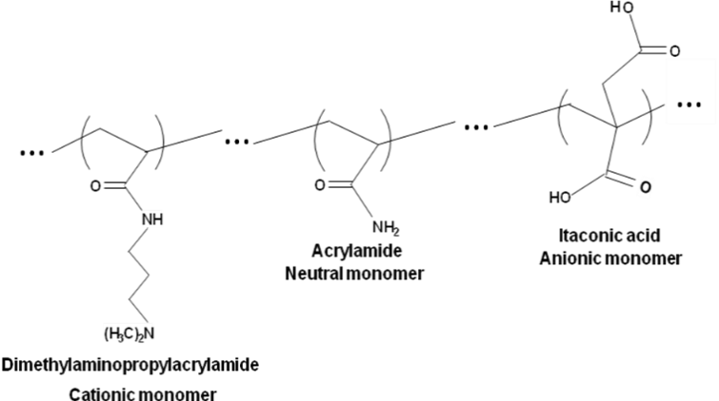

Figure 1 - Polyampholyte molecular composition prepared by random, free-radical polymerization. (Bold, size 12)

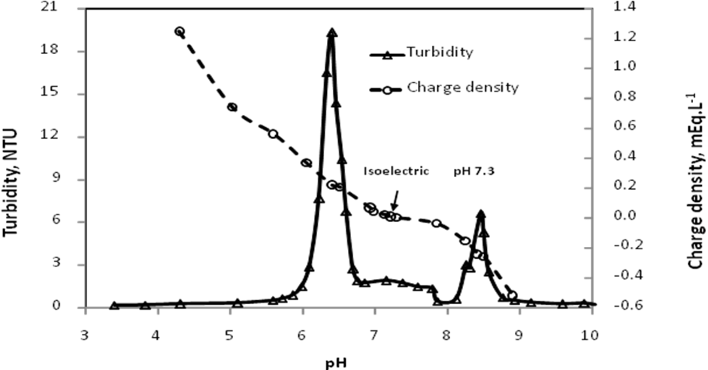
Figure 2 – Digital structure of a hybrid velocity/position fuzzy-PID controller.

3. Tables
Tables and/or charts must be adapted or adjusted to the page window and must be shown after and as close as possible from the point where they are cited in the text. Their captions must be aligned to the left just before the table itself with single spaces before and after the text, and must be typed as: Table 1 – Caption of the table, with a final dot. All tables must be cited in the text, as in the example: “The results of the experimental planning are shown in Table 1.” The measuring units of all parameters discussed in the work must be clearly declared, preferably in the International System format. It is recommended that a slash (/) be used to separate the name of the parameter and its corresponding unit whenever possible (see example on the table below; this format may also be used in the captions of graph axes).

Table 1 – Fuzzy rules for controllers Fuzzy-PI and Fuzzy-PID.
Fuzzy-PI controller
Δe(k)|e(k) | NL | NM | NS | ZR | PS | PM | PL
PL | ZR | PS | PM | PL | PL | PL | PL
PM | NS | ZR | PS | PM | PL | PL | PL
PS | NM | NS | ZR | PS | PM | PL | PL
ZR | NL | NM | NS | ZR | PS | PM | PL
NS | NL | NL | NM | NS | ZR | PS | PM
NM | NL | NL | NL | NM | NS | ZR | PS
NL | NL | NL | NL | NL | NM | NS | ZR

Table 2 - Fiber Quality Analysis.
Parameter | Mean length / mm | Mean width / µm | Fines / % | Vessel / # | Vessel length / mm | Vessel width / µm
Arithmetic average | 0.719 | 16.43 | 0.689 | 6.5 | 0.533 | 133.48
Standard deviation | 0.006 | 0.096 | 0.059 | 2.082 | 0.032 | 9.194
Note: The number of fibers counted was 3000. The fine fraction was classified as such if the fibrous elements had an effective dimension between 0.05 and 0.2 mm. (Table notes must be given in Font Size 9 and aligned to the left)

4. Equations
All equations must be typed in italics after a 0-cm tabulation from the left margin of the column, with a consecutive numbering in Arabic numerals between parentheses right aligned. All equations must be cited in the text, according to the example: “Replacement of Equation 1 on Equation 3 gives Equation 5 ...”. If any equation is written in more than one line, the corresponding number must be given on the last line, also between parentheses and aligned to the left of the corresponding column. See example below.

$\frac{∂X}{∂t}=∇\left(D_{eff}∇X\right)$ (1)

where X is the moisture content, [kg H₂O/ kg dry mass], t is time, [s], and D_{eff} is the effective diffusivity, [m² s⁻¹].

5. Supplementary Material
Manuscripts Including NMR, IR, Mass Spectra, etc. Whenever a compound is synthesized or identified (new or already known), it is imperative that spectral data (data and spectra) as Supplementary Material is submitted along with the manuscript. Supplementary Material. This resource was created so that the main text of the manuscript would contain only the strictly necessary figures and tables. Contents for Supplementary Material should be placed at the end of the manuscript, after the References section. Whenever the Supplementary Material is present, a section named Supplementary Material, describing its content, should be created in the main text of the manuscript right after Conclusions. The text should also indicate the free access to the Supplementary Material at jCEC website. Graphical elements and tables for Supplementary Material should be sequentially numbered as in the following examples: Figure 1S, Figure 2S, Table 1S, Table 2S. The Supplementary Material is a separate document. If references are used, they should be listed at the end of the Supplementary Material and numbered as 1S, 2S, etc. Editors, at any time of the editing process, may ask authors to remove portion(s) of the manuscript and include it in the Supplementary Material.

Acknowledgements
The authors appreciate the ﬁnancial support from…

References
All references must be written in the formats given below, which are based on American Psychological Association – APA (alphabetical order or numerical order). They should all be cited in the text by the first author's surname of the first author of the reference, followed by “et al.”, it that is the case, and year of publication between parentheses, as in: “Reports by Smith et al. (2009) and Schmidt et al. (2012) showed that ...”. In case the citations appear after the main text, the following format is suggested: “... such results have already been discussed in the literature (Armstrong et al., 2014; Fischer et al., 2015; Williamson et al., 2013)”. In this case, note that alphabetical order by the author's surname must be observed to list these references. In the case of two authors, the reference must be cited as: “... according to Armstrong and Fischer (1995), ...”. If three or more authors are involved, cite only the first author and use “et al.”, as in the previous examples. If different reports by the same authors have been published in the same year, please use letters a, b, c... after the publication year, as in the example: “Works by Smith et al. (2005 a, b) showed that ...”.
The list of references must contain only items that have been cited in the main text, and should be presented in alphabetical order according to the first author's surname. The references should be aligned to the left, with a 1-cm tabulation from the second line. The surnames and initials of all authors should be declared, separated by semicolons. See examples below.

Basic Form:
(Doubts - Please see:
https://owl.purdue.edu/owl/research_and_citation/apa_style/apa_formatting_and_style_guide/general_format.html)
APA style dictates that authors are named with their last name followed by their initials; publication year goes between parentheses, followed by a period. The title of the article is in sentence-case, meaning only the first word and proper nouns in the title are capitalized. The periodical title is run in title case, and is followed by the volume number which, with the title, is also italicized. If a DOI has been assigned to the article that you are using, you should include this after the page numbers for the article. If no DOI has been assigned and you are accessing the periodical online, use the URL of the website from which you are retrieving the periodical.

Author, A. A., Author, B. B., & Author, C. C. (Year). Title of article. Title of Periodical, volume number (issue number), pages. https://doi.org/xx.xxx/yyyy

Articles in Journal:
Mota, A. S., Menezes, M. R., Schmitz, J. E., da Costa, T. V., da Silva, F. V., & Franco, I. C. (2016). Identification and online validation of a ph neutralization process using an adaptive network-based fuzzy inference system. Chemical Engineering Communications, 203(4), 516–526. doi: https://doi.org/10.1080/00986445.2015.1048799
Muftah, A. F. (2020). Productivity enhancement of stepped solar still integrated MEMS light sensors for solar tracker. The Journal of Engineering and Exact Sciences, 6(5), 0666-0667. https://doi.org/10.18540/jcecvl6iss5pp0666-0667
Siqueira, A. M. de O., Monteiro, S. A., Araújo, W. dos R. M., Silva, G. S., & Andrade, A. O. de. (2019). A preliminary investigation on teaching styles in higher education. International Journal of Advanced Engineering Research and Science, 6(1), 161–168. https://doi.org/10.22161/ijaers.6.1.22

Dissertations and theses:
Carmo, F. M. S. (2003). Estudo de polimorfismo do gene candidato, o fator miogênico-5 (myf -5), em suínos. Tese de Doutorado, Universidade Federal de Viçosa, Viçosa, MG, Brasil.
Costa, T. V. da. (2014). Estudo e implementação de estruturas de controle reconfigurável aplicado a processos químicos. Tese de Doutorado, Universidade Estadual de Campinas, Campinas, SP, Brasil.
Santos, M. L. (2001). Crescimento e alocação de biomassa e de nutrientes em eucalipto, decorrentes da aplicação de nitrogênio e potássio. Dissertação de Mestrado, Universidade Federal de Viçosa, Viçosa, MG, Brasil.

Works in proceedings of scientific events:
Fonseca, R. R., Franco, I. C., & Silva, F. V. da. (2016). Bioreactor temperature control using a generic fuzzy feedforward control system. 841: Intelligent Systems and Control. Modelling, Simulation and Identification / 841: Intelligent Systems and Control, Campinas, Brazil. https://doi.org/10.2316/P.2016.841-024

Books:
Seborg, D. (2011). Process dynamics and control. Wiley.

Submission Preparation Checklist

Please see the following link: https://periodicos.ufv.br/jcec/about/submissions.

