THE TITLE OF THE ARTICLE MUST BE IN FONT "TIMES NEW ROMAN" SIZE 16, IN BOLD, ALIGNED TO THE LEFT, WITH SINGLE SPACING IN CAPITAL LETTERS, WITHOUT FINAL DOT, AND PARAGRAPH SPACINGS OF 12 pt BEFORE AND 6 pt AFTER THE TEXT
(one SINGLE space, size 12)
TRANSLATION OF THE MANUSCRIPT'S TITLE TO ANOTHER LANGUAGE MUST BE IN FONT "TIMES NEW ROMAN" SIZE 12, IN BOLD, WITH FULLY-JUSTIFIED ALIGNMENT, WITH SINGLE SPACING IN CAPITAL LETTERS, WITHOUT FINAL DOT, AND PARAGRAPH SPACINGS OF 0 pt BEFORE AND 0 pt AFTER THE TEXT
(one SINGLE space, size 10)
A. B. SURNAME^{1,*}, C. SURNAME² and D. SURNAME³ (Times New Roman 12, lined to the left) [Please, suppress names or personal details of the authors in the original revision version. Only on the final accepted version will such information be published. For authors of the same given institution, please use the same identifying numbers]
(one SINGLE space, size 12)
¹ Federal University of XXXX, Department of Chemical Engineering, City, State, Country
² Federal University of XXXX, Institute of Chemistry, City, State, Country
³ Institute of XXXX, Research Department, City, State, Country
*Corresponding author. Federal University of XXXX, Department of Chemical Engineering, City, State, Country, Phone: +55 XX YYYYYYYY (In italics, size 8, lined to the left) [Please do not remove the line above; thickness 2 ¼ pt)
e-mail addressl: x.xxxx@xx.yyy.zz (A. B. Surname).
A R T I C L E I N F O |  | A B S T R A C T
Article history:  Received 2020-12-20  Accepted 2020-12-20  Available online 2020-12-20 |  | The abstract must be written in English as a single paragraph with font Times New Roman size 10, with single spacing and in italics. It must be aligned both to the left and right margins. NO references should be cited in the text, which must contain from 700 to 900 characters including spaces. As an example of how the abstract's format should be, a random text is given here. TEXT TEXT TEXT TEXT TEXT TEXT TEXT TEXT TEXT TEXT TEXT TEXT TEXT TEXT TEXT TEXT TEXT TEXT TEXT TEXT TEXT TEXT TEXT TEXT TEXT TEXT TEXT TEXT TEXT TEXT TEXT TEXT TEXT TEXT TEXT TEXT TEXT TEXT TEXT TEXT TEXT TEXT TEXT TEXT TEXT TEXT TEXT TEXT TEXT TEXT TEXT TEXT TEXT TEXT TEXT TEXT TEXT TEXT TEXT TEXT TEXT TEXT TEXT TEXT TEXT TEXT TEXT TEXT TEXT TEXT TEXT TEXT.
p a l a v r a s - c h a v e
Palavra 1 (TAMANHO 8)
Palavra 2 (TAMANHO 8)
Palavra 3 (TAMANHO 8)
Palavra 4 (TAMANHO 8)
[3 a 5 palavras chave]
(one SINGLE space, size 10)
k e y w o r d s
Word 1 (SIZE 8)
Word 2 (SIZE 8)
Word 3 (SIZE 8)
Word 4 (SIZE 8)
 |  | R E S U M O
 |  | Translation of the abstract to an appropriate language must be provided here. Please choose either Portuguese or Spanish, and adapt your list of keywords accordingly (see box to the left on this page). The same guidelines given above for the abstract must be followed here. As an example of how the abstract's format should be, a random text is also given here. TEXT TEXT TEXT TEXT TEXT TEXT TEXT TEXT TEXT TEXT TEXT TEXT TEXT TEXT TEXT TEXT TEXT TEXT TEXT TEXT TEXT TEXT TEXT TEXT TEXT TEXT TEXT TEXT TEXT TEXT TEXT TEXT TEXT TEXT TEXT TEXT TEXT TEXT TEXT TEXT TEXT TEXT.
The first page must not contain any information other than the ones defined above. The main body of the manuscript must come after this page break. No elements shown in this first page must appear in the following pages.

N O M E N C L A T U R E (FONT SIZE 12)
If necessary, a list of notations and used symbols must be given here, before the INTRODUCTION, together with their measuring units, in alphabetical order. Proper acknowledgments are usually made after the Conclusions.
1. INTRODUCTION (FONT SIZE 12)
(Please do not remove the line above; thickness 2 ¼ pt)
The title of each section is a first-order header and must be numbered with arabic numerals, aligned to the left in bold upper-case letters. Spacings of 6 pt before and 12 pt after the text must be given.
The text of the entire manuscript must be typed in single-line spacing, but double spacing must be given between paragraphs. The page format should be A4 (210 mm × 297 mm), in the “portrait” orientation mode, divided in two columns with narrow margin. The font must be Times New Roman, with size 12 in the main title and size 10 in the secondary title (second language); size 10 must also be given in the first-, second- and third-order headers, and also in the text; size 8 must be given in the authors' reference notes below the titles.
It is recommended that this template provided by jCEC be used to write the entire manuscript. That way, these guidelines will be properly observed. Articles written in Portuguese, English or Spanish must have the same format. The first line of each paragraph must start with a 1-cm tabulation from the left margin with fully-justified alignment. The manuscript must be written with a minimal of 7 (seven) and a maximal of 15 (fifteen) pages.
1.1 Second-Order Header (Font size 10)
The second-order headers must be aligned to the left margin and must be written in bold, with only the first letter of each word in upper case, separated from the previous text by a single space.
Third-order header (Font size 10): This header must start after a 1-cm tabulation from the left margin of this column, without numbering, and must be written with underlined characters. Only the first letter of the first word must be upper-case. The main text should start in the same line of the header.
2. FIGURES (FONT SIZE 12)
(Please do not remove the line above; thickness 2 ¼ pt)
Figures may be coloured or not, and must be inserted in the main body of the manuscript as close as possible from the point where they are cited in the text. They must be centralized and should not exceed the margins defined for the page. It is recommended that a minimal of 300-dpi resolution be used in digitized figures. They should be preferably saved in the JPG format. Each figure must have a caption in arabic numerals. The caption must be centralized just below the figure itself, and separated by a single space before the corresponding text and double space after it. The format to be followed is: Figure 1 – Caption of the figure, with a final dot. In the main text, they should necessarily be mentioned or cited as in the example: “As shown by Figure 1, ...” (See other examples below).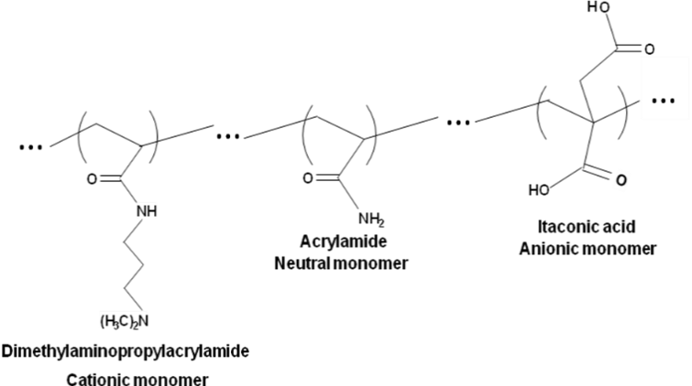
Figure 1 - Polyampholyte molecular composition prepared by random, free-radical polymerization. (Bold, size 10)
[If necessary, the figure may be inserted in a single column, provided a continuous section break is given. See example below]

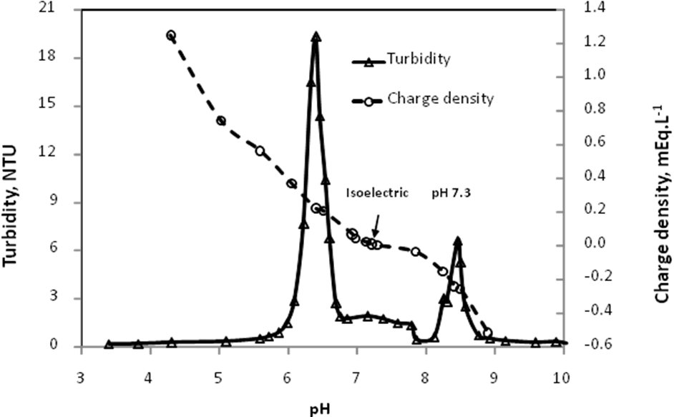
Figure 1 – Digital structure of a hybrid velocity/position fuzzy-PID controller.

3. TABLES
Tables and/or charts must be adapted or adjusted to the page window and must be shown after and as close as possible from the point where they are cited in the text. Their captions must be aligned to the left just before the table itself with single spaces before and after the text, and must be typed as: Table 1 – Caption of the table, with a final dot. All tables must be cited in the text, as in the example: “The results of the experimental planning are shown in Table 1.” The measuring units of all parameters discussed in the work must be clearly declared, preferably in the International System format. It is recommended that a slash (/) be used to separate the name of the parameter and its corresponding unit whenever possible (see example on the table below; this format may also be used in the captions of graph axes). The cells in the first or main line of the table must be filled in black and the text must be written in white letters. The cells in all other lines must be filled with a 15 % shade of grey (see examples here).
Table 1 – Fuzzy rules for controllers Fuzzy-PI and Fuzzy-PID.
Fuzzy-PI controller
Δe(k)|e(k) | NL | NM | NS | ZR | PS | PM | PL
PL | ZR | PS | PM | PL | PL | PL | PL
PM | NS | ZR | PS | PM | PL | PL | PL
PS | NM | NS | ZR | PS | PM | PL | PL
ZR | NL | NM | NS | ZR | PS | PM | PL
NS | NL | NL | NM | NS | ZR | PS | PM
NM | NL | NL | NL | NM | NS | ZR | PS
NL | NL | NL | NL | NL | NM | NS | ZR
[If necessary, one could highlight any data in the table (see example above). The table can also be inserted in a single column, provided a continuous section break is given (see example below).]

Table 1 - Fiber Quality Analysis.
Parameter | Mean length / mm | Mean width / µm | Fines / % | Vessel / # | Vessel length / mm | Vessel width / µm
Arithmetic average | 0.719 | 16.43 | 0.689 | 6.5 | 0.533 | 133.48
Standard deviation | 0.006 | 0.096 | 0.059 | 2.082 | 0.032 | 9.194
Note: The number of fibers counted was 3000. The fine fraction was classified as such if the fibrous elements had an effective dimension between 0.05 and 0.2 mm. (Table notes must be given in Font Size 9 and aligned to the left)

4. EQUATIONS
All equations must be typed in italics after a 0-cm tabulation from the left margin of the column, with a consecutive numbering in arabic numerals between parentheses aligned to the left of the corresponding column. It is recommended that Microsoft® Equation 3.0 be used, particularly because the manuscript file should be prepared in the DOCX format. All equations must be cited in the text, according to the example: “Replacement of Equation 1 on Equation 3 gives Equation 5 ...”. If any equation is written in more than one line, the corresponding number must be given on the last line, also between parentheses and aligned to the left of the corresponding column. See example below.
(1)
where X is the moisture content, [kg H₂O/ kg dry mass], t is time, [s], and D_{eff} is the effective diffusivity, [m² s⁻¹].

5. SUPPLEMENTARY MATERIAL
Manuscripts Including NMR, IR, Mass Spectra, etc. Whenever a compound is synthesized or identified (new or already known), it is imperative that spectral data (data and spectra) as Supplementary Material is submitted along with the manuscript. Supplementary Material. This resource was created so that the main text of the manuscript would contain only the strictly necessary figures and tables. Contents for Supplementary Material should be placed at the end of the manuscript, after the References section. Whenever the Supplementary Material is present, a section named Supplementary Material, describing its content, should be created in the main text of the manuscript right after Conclusions. The text should also indicate the free access to the Supplementary Material at jCEC website. Graphical elements and tables for Supplementary Material should be sequentially numbered as in the following examples: Figure 1S, Figure 2S, Table 1S, Table 2S. The Supplementary Material is a separate document. If references are used, they should be listed at the end of the Supplementary Material and numbered as 1S, 2S, etc. Editors, at any time of the editing process, may ask authors to remove portion(s) of the manuscript and include it in the Supplementary Material.

R E F E R E N C E S
All references must be written in the formats given below, which are based on Brazilian regulations ABNT NBR 6023 and 10520. They should all be cited in the text by the first author's surname, followed by “et al.”, it that is the case, and year of publication between parentheses, as in: “Reports by Smith et al. (2009) and Schmidt et al. (2012) showed that ...”. In case the citations appear after the main text, the following format is suggested: “... such results have already been discussed in the literature (Armstrong et al., 2014; Fischer et al., 2015; Williamson et al., 2013)”. In this case, note that alphabetical order by the author's surname must be observed to list these references. In the case of two authors, the reference must be cited as: “... according to Armstrong and Fischer (1995), ...”. If three or more authors are involved, cite only the first author and use “et al.”, as in the previous examples. If different reports by the same authors have been published in the same year, please use letters a, b, c... after the publication year, as in the example: “Works by Smith et al. (2005 a, b) showed that ...”.
The list of references must contain only itens that have been cited in the main text, and should be presented in alphabetical order according to the first author's surname. The references should be aligned to the left, with a 1-cm tabulation from the second line, and separated with single spaces. The surnames and initials of all authors should be declared, separated by semicolons. See examples below.

ARTICLES IN PERIODICALS:
NARDELLI, A. M. B.; GRIFFITH, J. J. Modelo teórico para compreensão do ambientalismo empresarial do setor florestal brasileiro. Revista Árvore, Viçosa, MG, v.27, n. 6, p. 855-869, nov./dez. 2003.
NARDELLI, A. M. B.; GRIFFITH, J. J. Theoretical model for understanding corporate environmentalism in the Brazilian forestry sector. Rev. Árvore, Viçosa, MG, v. 27, n. 6, p. 855-869, Nov./Dec. 2003. Available at: <http://www.scielo.br/pdf/rarv/v27n6/a12v27n6.pdf>. Accessed on October 11th, 2004.

DISSERTATIONS AND THESES:
CARMO, F. M. S. Estudo de polimorfismo do gene candidato, o fator miogênico-5 (myf -5), em suínos. 2003. 69 f. Tese (Doutorado em Zootecnia) - Universidade Federal de Viçosa, Viçosa, MG, 2003.
SANTOS, M. L. Crescimento e alocação de biomassa e de nutrientes em eucalipto, decorrentes da aplicação de nitrogênio e potássio. 2001. 62 f. Dissertação (Mestrado em Ciências do Solo) - Universidade Federal de Viçosa, Viçosa, MG, 2001.
CARNEIRO, N. M. Q. Procedimentos básicos para o planejamento de uma indústria de biscoitos, enfocando a legislação sanitária de alimentos do estado de Minas Gerais. 2004. 90 f. Monografia (Especialização em Nutrição e Saúde) - Universidade Federal de Viçosa, Viçosa, MG, 2004.

WORKS IN PROCEEDINGS OF SCIENTIFIC EVENTS:
ORLANDO SOBRINHO, J.; SILVA, L. E. Resposta à calagem. In: SEMINÁRIO SOBRE CORRETIVOS AGRÍCOLAS, 2., 1985, Campinas. Anais... Campinas: Fundação Cargill, 1985. p. 123-157.

ELECTRONIC REFERENCES:
FAINTUCH, J. Nutrição parenteral. São Paulo: CAD, 2001. Available at: <http://www.fugesp.org.Br/nutriesaude3-4htm>. Accessed on September 3rd, 2001.

BOOKS:
HUBERMAN, L. História da riqueza do homem. 21st ed., Rio de Janeiro: LTC, 1986.

GENERAL PROVISIONS
a) During the on-line submission process, the full names of the authors, their affiliations and the e-mail address of the corresponding author must be provided;
b) The manuscripts must contain the following sections: Abstract (and Resumo or Resumen in the alternative Portuguese or Spanish languages); Keywords (and Palavras-chave or Palabras clave); Introduction, Materials and methods, Results and discussion, Conclusion, Supplementary Material (Optional), Acknowledgements (Optional) and References.
c) The title must be precise and contain no more than 20 (twenty) words.
d) The abstract with no more than 900 characters (including spaces) must contain succinct information on the main objective of the work, the experimental methodology, results and conclusion. Up to five keywords should be listed.
e) The initial file containing the work that will be submitted to analysis must be attached on line. On this initial version, please do not include any information that can identify the authors. It should be pointed out that peer blind revision is encouraged by the journal. Only after acceptance of the revised manuscript will such information be published, and the authors will be required to include it in the final version.
f) The International System of Units must be adopted in the manuscript.
g) All parameters shown in equations must be clearly identified in the text.
h) Although the manuscript may be edited with specific word-editor software, submission must be affected in both PDF (which will be subjected to peer review) and .DOCX format.

SUBMISSION PREPARATION CHECKLIST

As part of the submission process, authors are required to check off their submission's compliance with all of the following items. Submissions may be returned to authors who do not adhere to these guidelines.
- The submission has not been previously published, nor is it presented to another journal for consideration (or an explanation has been provided in Comments to the Editor).
- The submission file is in the PDF document file format, following the jCEC template.
Template:
https://periodicos.ufv.br/jcec/article/view/9460
- A list of ad-hoc reviewers must be suggested by the authors in a different PDF file, containing at least three names (full name, e-mail address, affiliation and area of expertise (if possible). It is recommended that this list does not contain names of ad-hoc reviewers that are already enrolled with the jCEC (please see updated list on the journal website, particularly on the edition of v. 5, n. 5, 2019).
- The identification of authorship of any paper must be removed from the Word file and the option "Properties in Word", thereby ensuring the confidentiality of the journal. The text meets the formatting standards of the journal cited in “Guidelines for authors” in the “About” section.
- A version of the manuscript, edited in the DOCX format must be included as a supplementary document.
- The COVER PAGE FOR AUTHORS FORM in the scanned format must be included as a supplementary document.
Cover Page for Authors Form:
https://periodicos.ufv.br/jcec/article/view/9476
- If the article is accepted for publication, the authors acknowledge that they must pay the corresponding publication fee, defined by the Editorial Team, in the link: https://eventos.funarbe.org.br/detalhes/pagamento-de-taxa-de-publicacao-para-o-jCEC-journal.

- OTHER CHECKLIST POINTS:

ABSTRACT / SUMMARY
- Is the abstract intelligible?
- Does the abstract accurately describe the objectives and results obtained?
- Does the abstract include data not presented in the paper?
- Does the abstract include material that cannot be substantiated?
INTRODUCTION
- Did the authors indicate why the study was undertaken?
- Was the provided background information adequate to understand the aims of the study?
METHODS
- Were the methods described in sufficient detail for others to repeat or extend the study?
- If standard methods were used, were adequate references given?
- If methods were modified, were the modifications described carefully?
- Have the authors indicated the reasons why particular procedures were used?
- Have the authors indicated clearly the potential problems with the methods used?
- Have the authors indicated the limitations of the methods used?
- Have the authors specified the statistical procedures used?
- Are the statistical methods used appropriate?
RESULTS
- Were the experiments done appropriate with respect to objectives of the study?
- Do the results make sense?
- Do the legends to the figures describe clearly the data obtained?
- Are the data presented in tabular form clear?
- Are the legends to the tables clear?
- Has appropriate statistical analysis been performed on the data?
DISCUSSION
- Were the objectives of the study met?
- Do the authors discuss their results in relation to available information?
- Do the authors indulge in needless speculation?
- If the results obtained were statistically significant, were they also scientifically significant?
- If the objectives were not met, do the authors have any explanation?
- Do the authors adequately interpret their data?
- Do the authors discuss the limitations of the methods used?
- Do the authors discuss only presented data or do they refer consistently to unpublished work?
REFERENCES
- Do the authors cite appropriate papers for comments made?
- Do the authors cite their own publications needlessly?

- Authors declare that they have read all the previous items and that they agree with them.

PEER-REVIEW PROCESS

Articles will be reviewed by three ad-hoc members of the editorial committee, according to the contents of the article and the specific area of expertise, through the “blind peer review” process, guaranteeing impartiality in the evaluation. Papers submitted to the journal will undergo an editorial process comprising several stages. First, received articles will be subjected to a preliminary assessment by members of the Editorial Board, which will determine the relevance of their publication. Having established that the article meets the thematic requirements, as well as the formal requirements listed in the section Author Guidelines, it will be sent to three external reviewers (ad hoc), specialists in the journal's areas of interest, using the "double blind" system, and they will anonymously determine: a) the publication of the article, unmodified; b) the publication of the article, after minor modifications; c) the review of the article by a fourth reviewer; or d) not to publish the article. If the reviewers' decisions differ, the paper will be reviewed by a different reviewer, whose decision shall define if the article is to be published or not. Prior to the acceptance of a paper and as a final step, the paper is checked with iThenticate, a powerful plagiarism detection software, in order to guarantee the quality of papers being published in jCEC. The papers with 20% or more similarities with any other published journal papers are rejected. Finally, the reviewers' decision will be communicated to the author(s) of the work.

